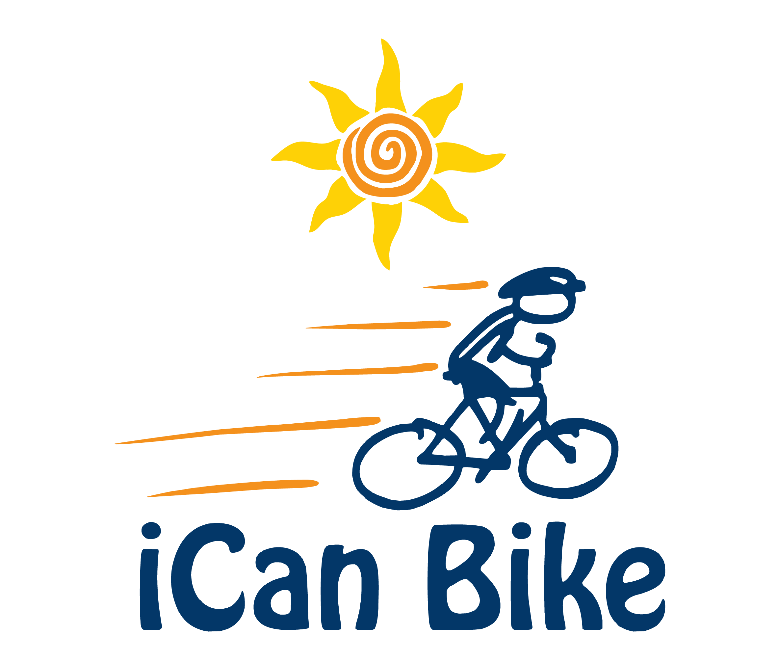

E-mail Response to Rider Inquiry

Hi interested participant,

Thank you for your interest in our iCan Bike camp scheduled for June 17th – June 21st 2019

Click the below link for access to the iCan Bike website for more information and to view a number of short videos of the iCan Bike camp:

www.icanshine.org

Our iCan Bike camp:

- is for individuals with disabilities who are 8 years old or older
- has approximately 40 riders in the total camp; however, because there are five 75-minute sessions each day, there will be no more than 8 riders at any one time at camp which ensures more individualized attention for your rider.
- requires each rider attend the same 75-minute session for each of the 5 days (M – F)
- invloves each rider being assigned the same two volunteers that will work with the rider each day. This works great because bonds are formed between the volunteers and riders that is helpful for encouragement and motivational purposes throughout the week. Our goal is to provide these consistent people to create a predictable and safe environment for your rider each day.
- requires parents and/or guardians remain at camp and watch from nearby seating. A parent or guardian must remain present at camp at all times during the 75-minute session (dropping off the rider is not permitted).
- requires parents and/or guardians bring the rider’s personal bike, that they will be riding after the end of bike camp, to camp no later than the fourth day (Thursday). The goal is for the iCan Bike staff to ensure the bike is appropriate for the rider and transition the rider to their personal bike on the last (fifth) day of camp.

Daily 75-Minute Sessions:

[8:30 am - 9:45 am]
[10:05 am - 11:20 am]
[11:40 am - 12:55 pm]
[2:00 pm - 3:15 pm]
[3:35 pm - 4:50 pm]

The riders will be riding a specialized adapted bicycle designed to teach them to balance appropriately for the entire 75 minutes each day while being accompanied by their assigned volunteers. Additionally, camp staff will provide fun motivational teaching on a specially designed tandem bike that is generally well received by most riders.

The first two days of the bike camp (Mon & Tues) will take place solely inside on adapted roller bikes. Beginning on the third day (Wed), some riders may graduate to a two-wheel bike and transition to riding outdoors spotted by their assigned volunteers. As riders graduate from the roller bikes to a two-wheel bike between Wednesday and Friday, they will transition to the outdoor riding area.

I hope this provides you with helpful information about the program. I attached a registration form that provides all the information you need to know about registering.

Sincerely,

Bridgett Barkalow

