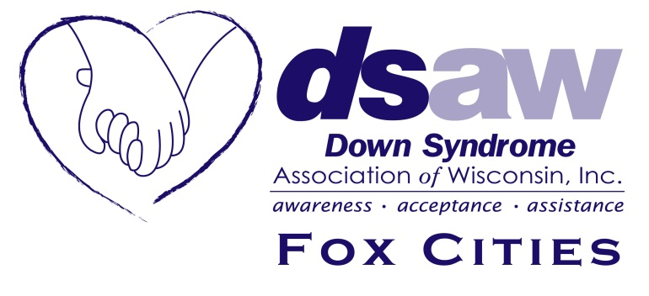
I Can Shine! Grant Application
Each DSAW-Fox Cities supported family is entitled to one DSAW-Fox Cities’ I Can Shine grant per individual with Down syndrome per year, for the full bike camp fee amount payable to DSAW, until the DSAW-Fox Cities budgeted maximum is met.

I Can Shine bike camp takes place annually in late June, in various areas in the state (may change yearly). Full details can be found on the DSAW website www.dsaw.org

“DSAW-Fox Cities’ supported family” is defined as the immediate family/guardian of an individual with Down syndrome that is currently listed on the DSAW-Fox Cities database and residing in Outagamie, Winnebago, or Calumet County. If a family resides outside of these three counties and is not already a supported family of another DSAW chapter, this family must be actively participating (attending DSAWFox Cities social events, fundraising for DSAW-Fox Cities, and/or active on the DSAW-Fox Cities Google email group) to be considered a supported family.

Please complete the I Can Shine grant application and mail to:
DSAW Fox Cities
211 E Franklin St or email to: info@dsawfoxcities.org
Appleton, WI 54911

Parent’s name:_____________________________________________________________________

Street address: _____________________________________________________________________

City, State, Zip: ________________________________________________________________

County of residence: ________________________________________________________________

Phone: _____________________________________________________________________

Email Address: ________________________________________________________________

ICS participant’s name: _________________________________________________________

ICS participant’s birth month/year: _____________________________________________

