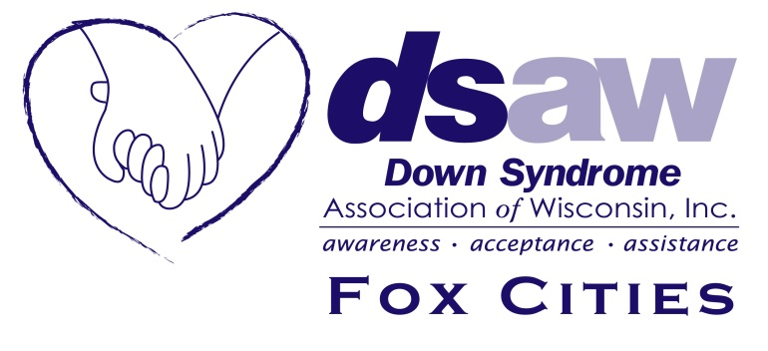
DSAW Fox Cities Adoption Grant Application

An adoption grant is available up to the amount of $2000 for qualifying families.
Rules for DSAW

- The DSAW Board at the state level must vote to approve the expense
- 2/3 Board approval required to award scholarship
- The DSAW Fox Cities Board must vote on complete applications
- Awards are made at the sole discretion of the DSAW Boards
- Individuals may apply once per adoption
- Families may request one grant per year, per family
- Awards are made until the dollars budgeted are exhausted

Requirements for Applicant

- Must live in the 3 county area that DSAW-Fox Cities serves (Outagamie, Winnebago, Calumet)
- Must join DSAW-Fox Cities as a supported family
- The adopted child must have Down syndrome
- Available for domestic or international adoptions
- Grant funds payable upon successful completion of court for the adoption

Completed application should be sent to:
Down Syndrome Association of Wisconsin
211 E Franklin St
Appleton, WI 54911

Or submitted electronically to:
info@dsaw.org with “Adoption Grant” in the subject line

The review period for applications is typically 100 days.
DSAW Fox Cities Adoption Grant Application

To complete application, please enclose:
- This completed DSAW-Fox Cities adoption application
- Proof of finalized adoption (court decree, new birth certificate, etc)
- Medical records or other information confirming diagnosis of Down syndrome
- Proof of adoption related expense in the amount of the grant or greater
  - Agency or attorney fees
  - Travel expenses (airplane, hotel)
  - USCIS fees
  - Paper filing fees (court, apostille)

DSAW POST-SECONDARY EDUCATION SCHOLARSHIP APPLICATION

Date _______________

Applicants Names __________________________________________________

Address _________________________________________

_________________________________________

County _______________________________

Phone ________________ E-mail Address _______________________________

Where are you adopting from? __________________________________________

Birthdate of Child: ___________________ Child’s Name: ___________________________________

Date of court for adoption: ________________

Are you an existing DSAW-Fox Cities supported family? ___________

